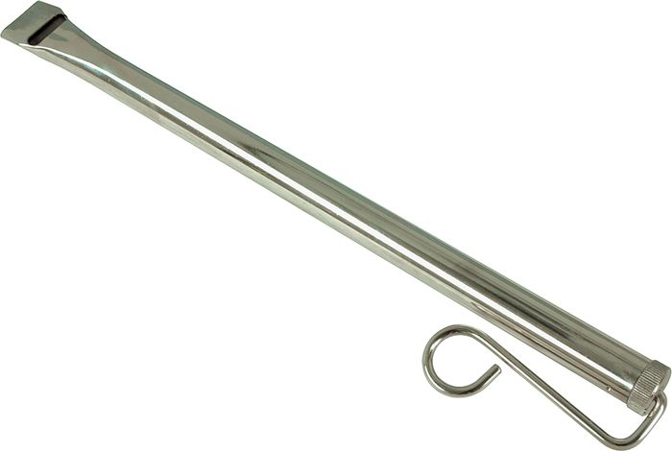

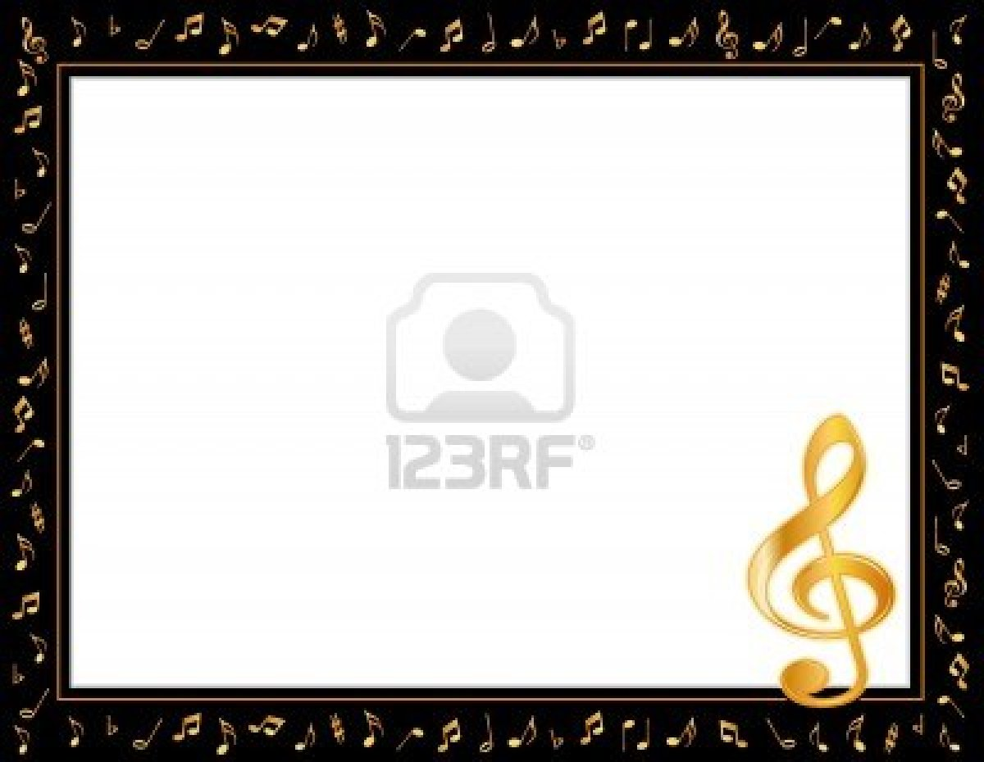

**ASK ME**

**about the slide whistle**

This week we discovered how to make our voices go high and low as we followed the direction of the slide whistle. The bottom slides back and forth and can make the whistle sound like a siren. We each used our own “slide whistle” to follow the teacher with our voices. Ask me to show you mine!

Note to parents: this is called “vocal exploration.” Young children have an easier time singing in their correct voice after they practice “exploring” the different directions their voices can go.



**ASK ME**

**about the slide whistle**

This week we discovered how to make our voices go high and low as we followed the direction of the slide whistle. The bottom slides back and forth and can make the whistle sound like a siren. We each used our own “slide whistle” to follow the teacher with our voices. Ask me to show you mine!

Note to parents: this is called “vocal exploration.” Young children have an easier time singing in their correct voice after they practice “exploring” the different directions their voices can go.