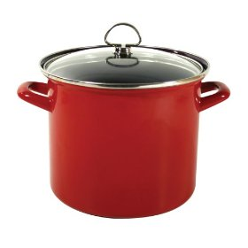**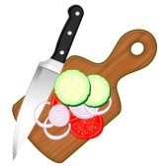******



**ASK ME**

**about my Fingerplay**

**Chop, chop, chippity chop, *(one hand “chops” on a “cutting board”- the other hand)***

**Cut off the bottom and cut off the top. *(move hand to show bottom & top)***

**What there is left, we’ll put in the pot. *(scoop vegetables and put in the pot)***

**Chop, chop, chippity chop. *(resume tapping on arm)***

**What kinds of things do you put in soup? Chop them up!**

**Fingerplays are short rhymes/poems that work on expressiveness and dexterity, among lots of other things!**



**ASK ME**

**about my Fingerplay**

**Chop, chop, chippity chop, *(one hand “chops” on a “cutting board”- the other hand)***

**Cut off the bottom and cut off the top. *(move hand to show bottom & top)***

**What there is left, we’ll put in the pot. *(scoop vegetables and put in the pot)***

**Chop, chop, chippity chop. *(resume tapping on arm)***

**What kinds of things do you put in soup? Chop them up!**

**Fingerplays are short rhymes/poems that work on expressiveness and dexterity, among lots of other things!**