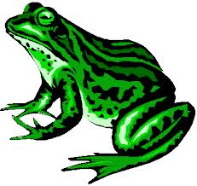



**ASK ME**

**about my frog song**

**Sing this song for two people!**

Frog in the meadow, *stir the frog around your nose, hand, nose,*

Can’t get him out. *head, toes, knees, legs, etc.*

Take a little stick

And stir him about.

*What other places can you think of to stir?*

*Don’t forget to use your other hand- or both hands!*

*We played a guiro: a ribbed wooden instrument that, when rubbed with a mallet, actually makes a sound like a frog!*



**ASK ME**

**about my frog song**

**Sing this song for two people!**

Frog in the meadow, *stir the frog around your nose, hand, nose,*

Can’t get him out. *head, toes, knees, legs, etc.*

Take a little stick

And stir him about.

*What other places can you think of to stir?*

*Don’t forget to use your other hand- or both hands!*

*We played a guiro: a ribbed wooden instrument that, when rubbed with a mallet, actually makes a sound like a frog!*